ARCHITHA OJHA
2303A52170 – 41

Backend API Development: Creating RESTful services with AI

Task 1: Initial API Setup for a Service Platform
Scenario
You are developing the backend for a service management platform and
need a basic API to confirm that the backend is running.
Task Description
• Use AI assistance to generate a basic Flask application.
• Create a root endpoint /status that returns a JSON message indicating
the API is live.
• Run the server locally and verify the response using a browser or API
testing tool.
Expected Output
• Accessing /status returns:
{"status": "API is running"}
• Flask server runs without errors.
Prompt:
"Act as a backend developer. Generate a minimal Flask application script with a single route /status that returns a JSON object: {"status": "API is running"}. Ensure the server runs on port 5000."

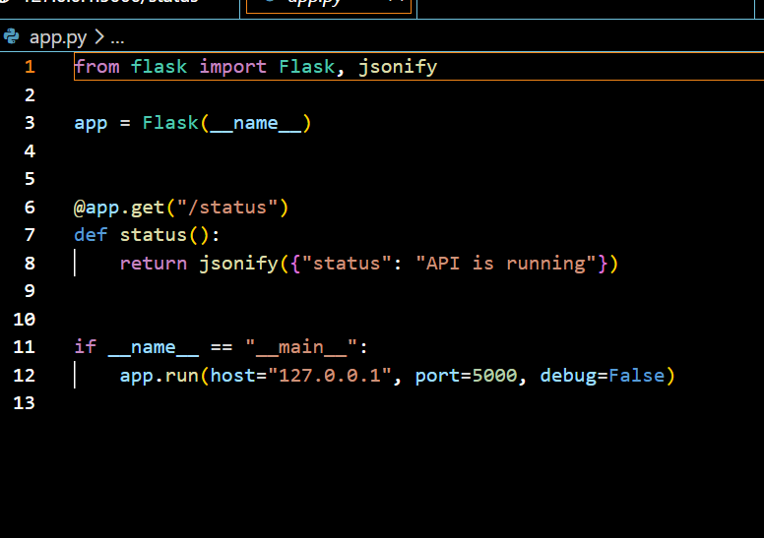
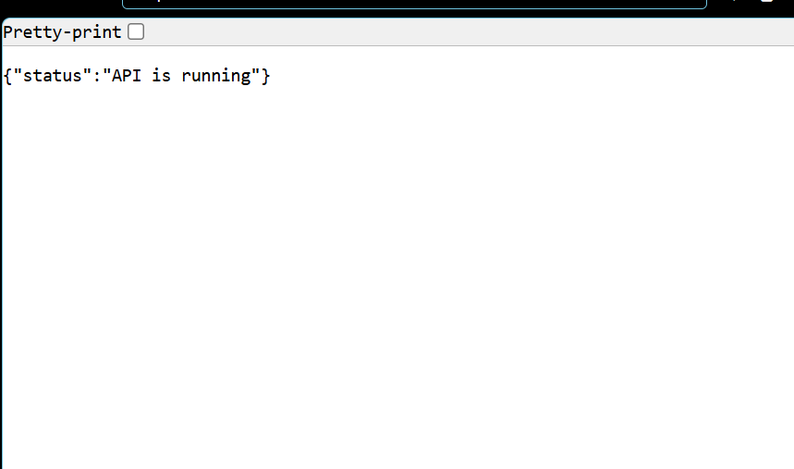

Justification:
This establishes the "heartbeat" of the project. Using AI to generate the boilerplate code ensures the environment is configured correctly from the start, allowing us to focus on logic rather than import syntax.

Task 2: Create API to Add and View Resources
Scenario
Your backend needs to manage customer service requests stored temporarily
in memory.
Task Description
• Use AI to help implement:
o A GET endpoint to retrieve all service requests
o A POST endpoint to add a new request
• Each request should contain title and priority.
Expected Output
• GET /requests returns an empty list initially
• POST /requests with:
{"title": "Internet issue", "priority": "High"}
returns confirmation with the added object
• Subsequent GET returns the added request
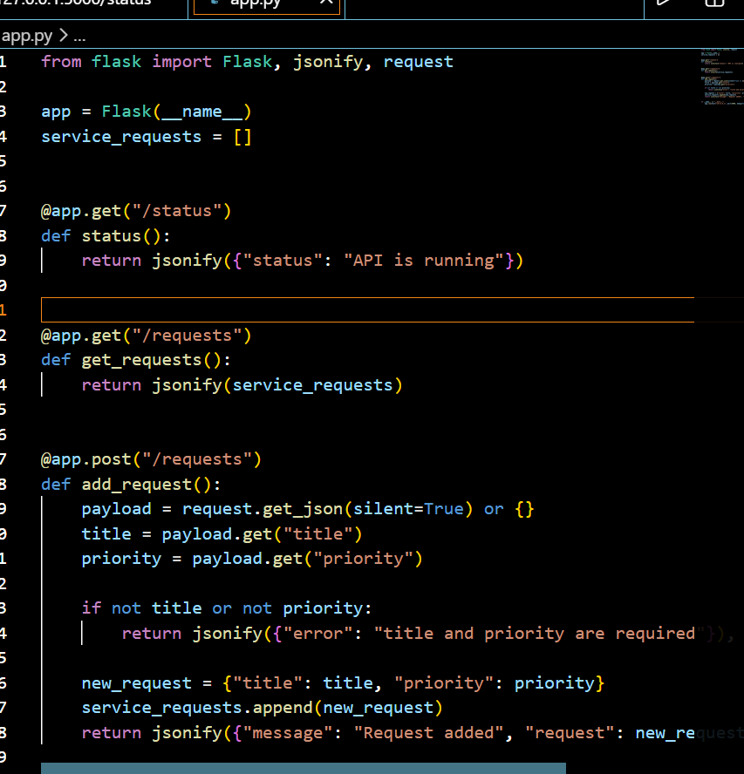
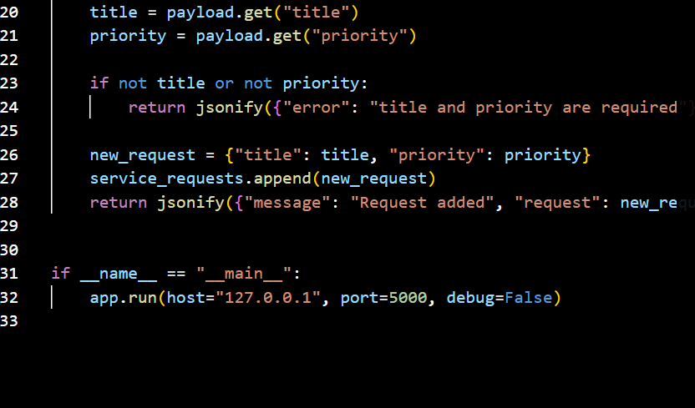
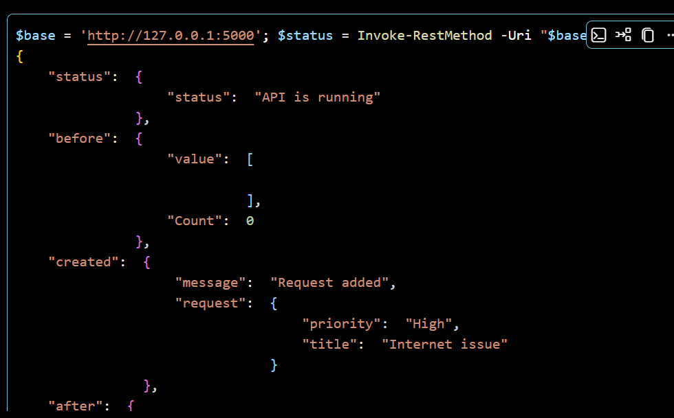
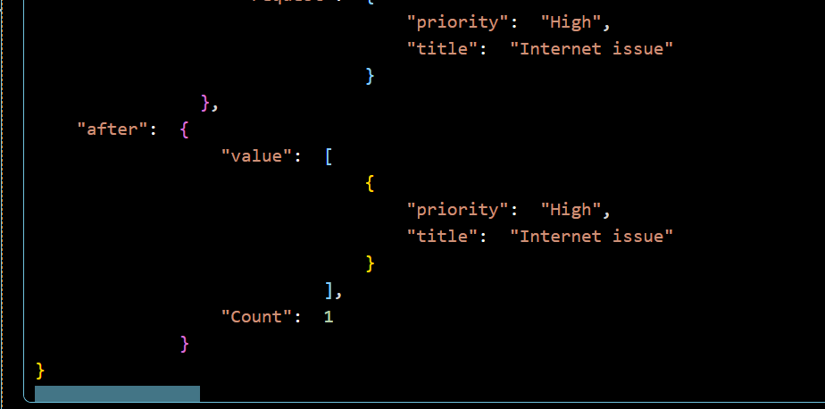
Justification:
This introduces data persistence (even if temporary). I used AI to quickly bridge the gap between a static status page and a functional data-handling API, which is the core of any service management tool.

Task 3: Modify Existing Resource Using AI Assistance
Scenario
Service requests may change in priority as issues are escalated.
Task Description
• Use AI to generate a PUT endpoint that updates a request based on its
index.
• Handle invalid indexes gracefully with proper error responses.
• Ensure the updated request is returned in the response.
Expected Output
• Valid update returns:
{"message": "Request updated", "request": {...}}
• Invalid index returns a clear error message with HTTP 404.

• Prompt:
"Write a PUT endpoint /requests/<int:request_id> that allows me to update a specific request by its index. If the index doesn't exist, return a 404 error with a message saying 'Request not found'. Otherwise, return the updated object."

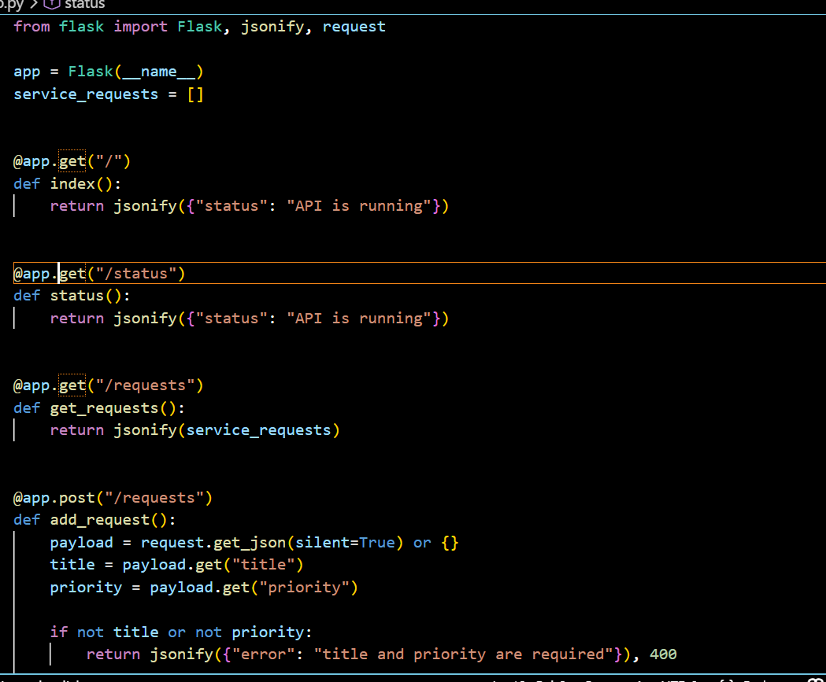
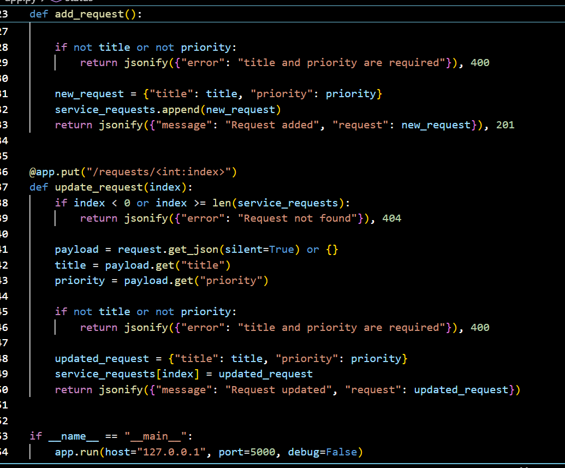
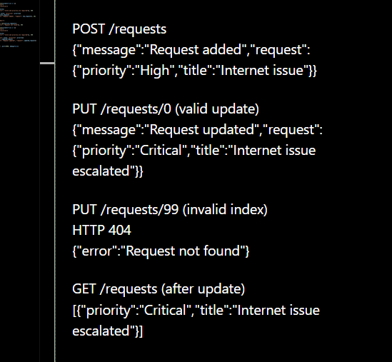
Justification:
Updating data is where logic gets tricky. I used AI to ensure the "edge cases"—like a user trying to update an index that isn't there—are handled gracefully without the server crashing.

Task 4: Remove a Resource Safely
Scenario
Resolved service requests must be removed from the active list.
Task Description
• Use AI assistance to implement a DELETE endpoint.
• The endpoint should remove a request by index.
• Return the deleted request details in the response.
Expected Output
• Successful deletion returns confirmation and removed data
• Invalid index returns an error message without crashing the server
•
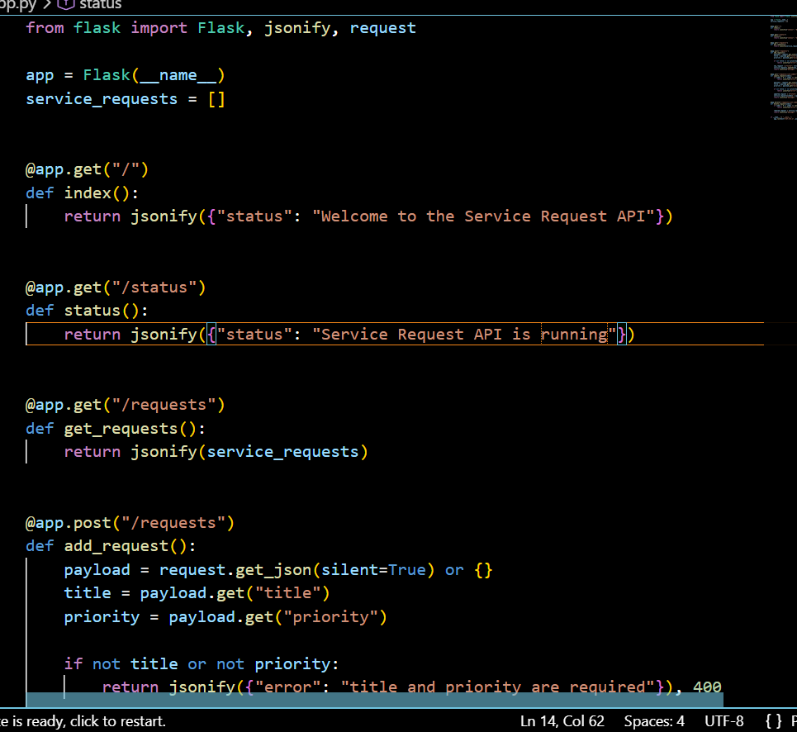
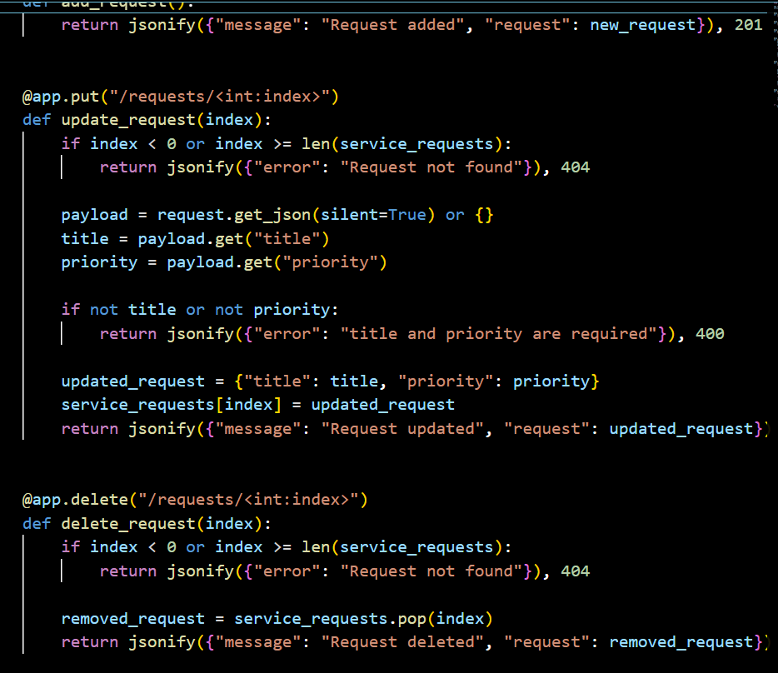
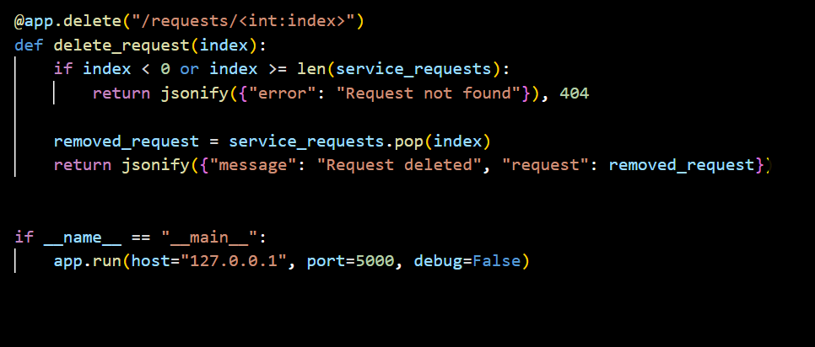

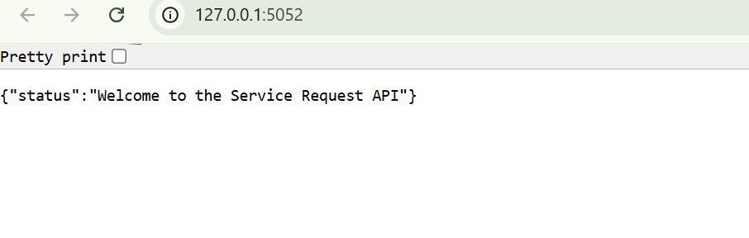
Justification:
Deleting data requires precision. This prompt uses AI as a safety net to implement "defensive coding," ensuring that removing a record doesn't lead to index errors or data corruption in the remaining list.

Task 5: AI-Assisted API Documentation and Readability
Scenario
Another developer needs to understand and use your API without reading the
full code.
Task Description
• Use AI to:
o Add meaningful docstrings and inline comments to all
endpoints
o Clearly describe request methods, inputs, and responses
• Optionally, use AI guidance to integrate automatic API documentation
(Swagger or Flask-RESTX).
Expected Output
• Well-documented endpoints with readable docstrings
• If implemented, a documentation UI displaying:
o Endpoint paths
o HTTP methods
o Sample request/response formats
Prompt:
"Review my Flask code and add professional Google-style docstrings to every function. Then, explain how I can use Flask-Smoreali or simple inline comments to clearly document the expected JSON input for the POST and PUT methods."

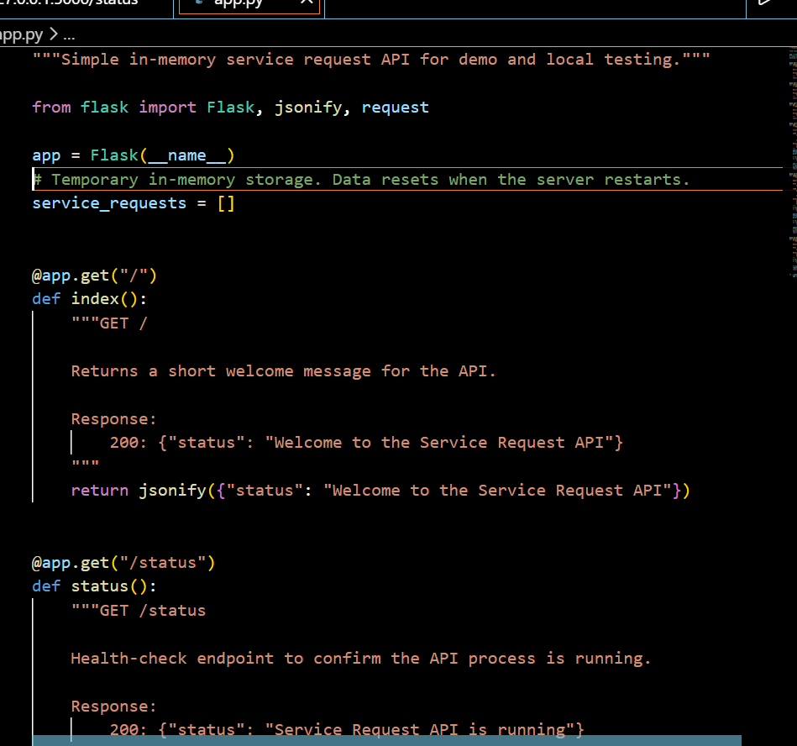
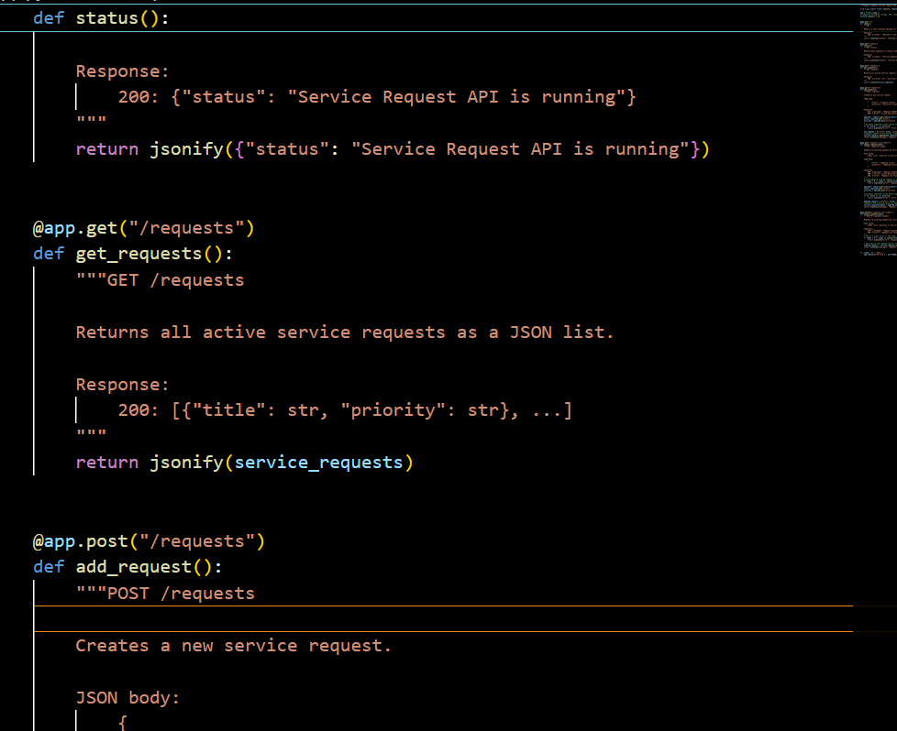
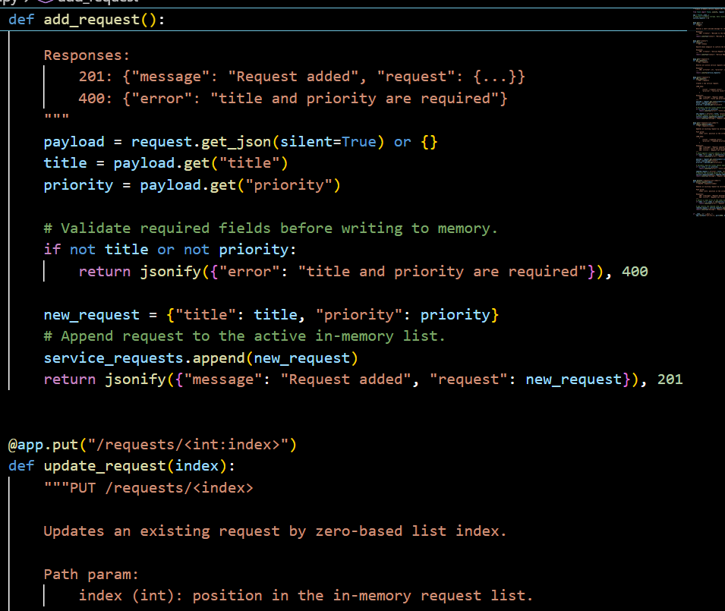
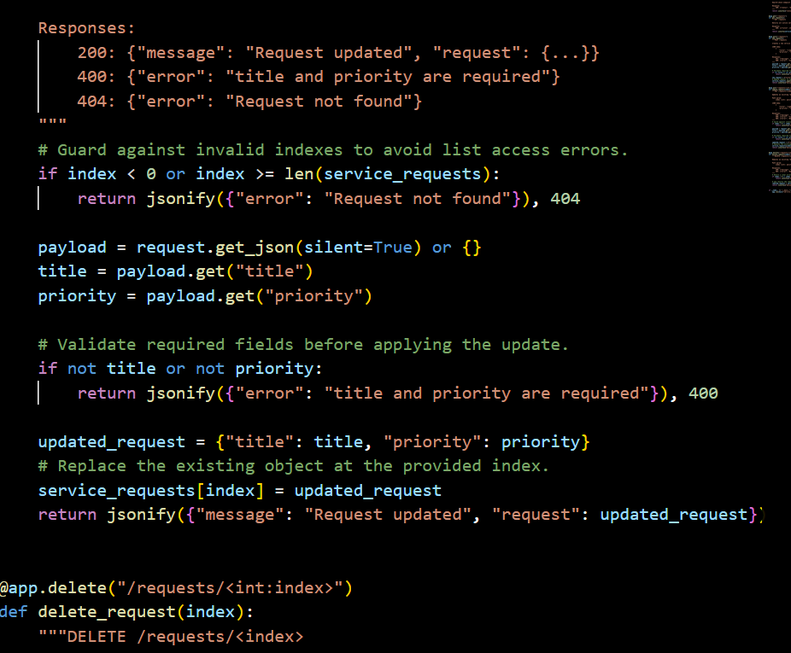
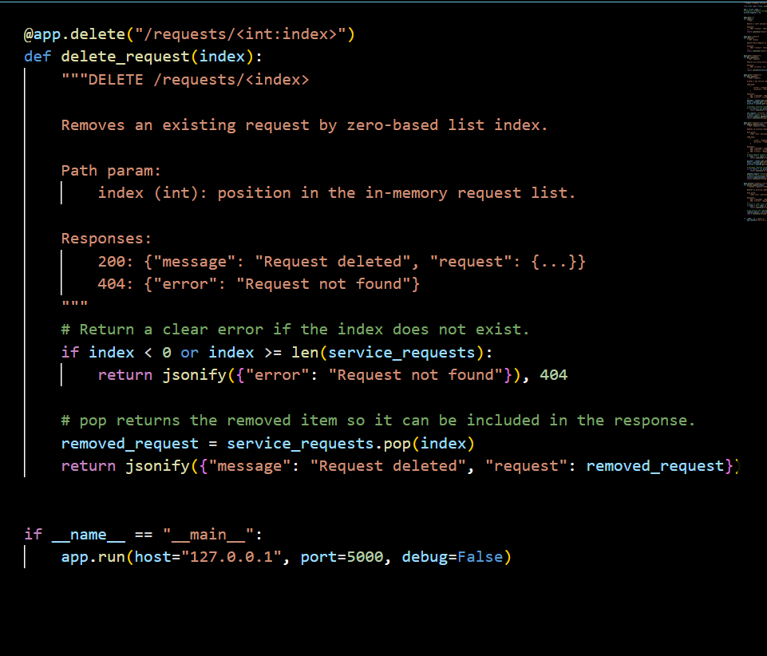
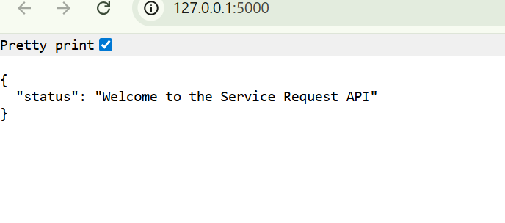
Justification: Clean code is just as important as working code. I leveraged AI to transform "raw" logic into a readable project, making it easier for future collaborators to understand the API's requirements without needing a guided tour.

